Eye Rhyme Couplets
Here’s a structured entry for:

🎯 What is Eye Rhyme Couplets
# Source: AI Source: Provided by: [Data Path: Persons Table -> ID Column: 1, Name_En Column: Motasem Essam] -> From: [Chatgpt (GPT-4-turbo)] on [8/2/2025]
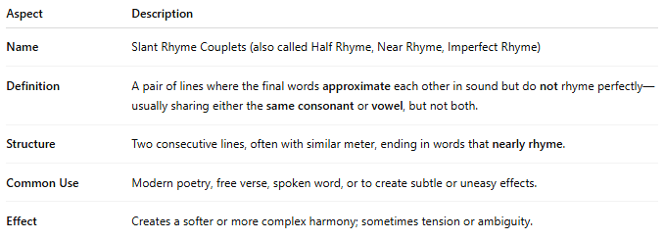
Aspect | Description
Name | Eye Rhyme Couplets (Visual Rhyme)
Definition | A pair of lines ending in words that look like they should rhyme based on spelling but do not sound alike when spoken.
Structure | Two lines where the rhyme is suggested visually rather than audibly.
Common Use | Traditional or playful poetry; often intentional to surprise or amuse the reader.
Effect | Creates a dissonance between appearance and sound, highlighting visual patterns or poetic irony.

✅ Example of Eye Rhyme in a Couplet
# Source: AI Source: Provided by: [Data Path: Persons Table -> ID Column: 1, Name_En Column: Motasem Essam] -> From: [Chatgpt (GPT-4-turbo)] on [8/2/2025]
She read the tale without a frown
And smiled beneath the oaken bough
- "frown" and "bough" look like they rhyme due to similar spelling endings (-own / -ough) but are pronounced very differently:
  - frown → /fraʊn/
  - bough → /baʊ/

